# Lecture 4. **Decision Control Statements in C**

* **if** statement
* **if-else** and **else-if** statements

# if Statement

### **if** statement is used to make a decision based on a condition.

* Condition can be an expression (examples: if(x + y) or if(num1>5)) of a direct value (example: if(5))
* If the expression produces zero, or direct value is zero, the condition becomes FALSE. For all other values, the condition is TRUE.

Examples:

if(10) is TRUE

if(0) is FALSE

if(x + y) is TRUE if (x+y) is not equal to zero

if(num1 > 5) is TRUE if the value of variable **num** is greater than 5

**Simple if statement**

### The **if** statement evaluates the condition. If it is TRUE, it executes the block of code that follows. If the condition is FALSE, it will skip this code.

* Used when there is only one option that is executed or not based on a condition.

Syntax

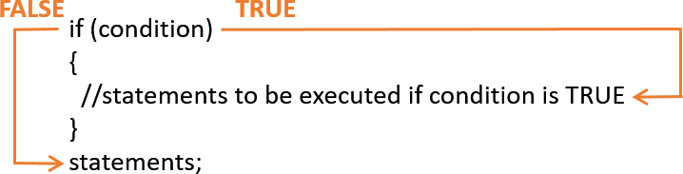

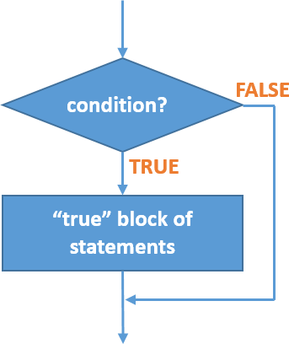

**if** Statement Flowchart

Example:

if (number < 0) //checks if number is a negative number

{

printf(“You entered negative number: %d”, number);

}

## if - else statement

### The **if-else** evaluates the condition. If it is TRUE, it executes the block of code that follows. If the condition is FALSE, it executes the second block of code.

Syntax

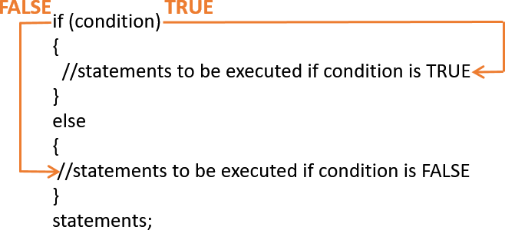

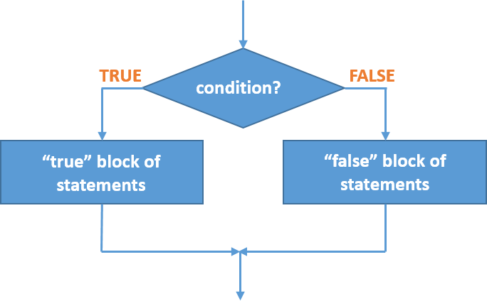

**if-else** Statement Flowchart

### Example:

if (number < 0) //checks if a number is a negative number

{

printf(“You entered negative number: %d”, number);

}

else

{

printf(“You entered zero or positive number: %d”, number);

}

## Nested if statement

### The if-else statement is **inside** another if-else statement

Syntax



Example:

if (number < 0) //checks if number is a negative number

{

printf(“You entered negative number: %d”, number);

}

else

{

if (number == 0) //checks if number is equal to zero

{

printf(“You entered zero”);

}

else

{

printf(“You entered positive number: %d”, number);

}

}

## if – else – if statement (if-else ladder)

### The if-else ladder allows for multiple test expressions to be checked and to execute different codes for more than two conditions.

Syntax



Example:

if(number < 0) //checks if number is a negative number

{

printf(“You entered negative number: %d”, number);

}

else if (number > 0) //checks if number is a positive number

{

printf(“You entered positive number: %d”, number);

}

else

{

printf(“You entered zero”);

}

## References

* Tan, H.H., and T.B. D’Orazio. *C Programming for Engineering & Computer Science*. USA: WCB McGRaw-Hill. 1999. Print.
* *C if, if...else and Nested if...else Statement*. N.p., n.d. Web. 09 Feb. 2017.

<<https://www.programiz.com/c-programming/c-if-else-statement>>.